**Hot Folder Integration for Product and Customer feeds.**

Use cases:

1. **Create hot-folder-store-sapbasket-spring.xml for your hot folder configuration.**

Implementation Flow:

1. Register hot-folder-store-sapbasket-spring.xml in <coreextension>-spring.xml.

<import resource=*"classpath:/sapbasketcore/integration/hot-folder-store-sapbasket-spring.xml"*/>

1. Create the bean and converter for Price update as follows

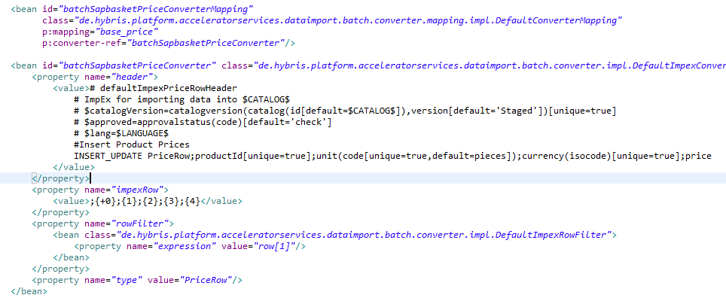

1. Similarly, you can create the bean and converter for any table you want to update in hybris system (Ex: Price, Customer feeds etc.) 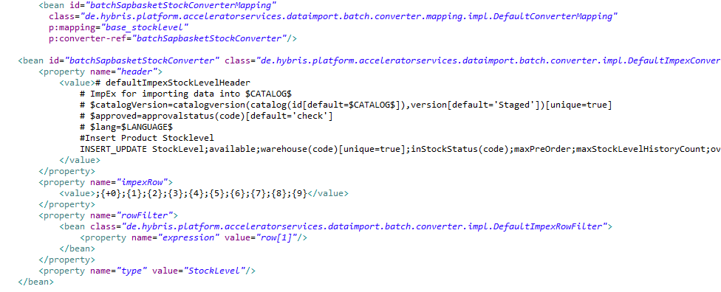

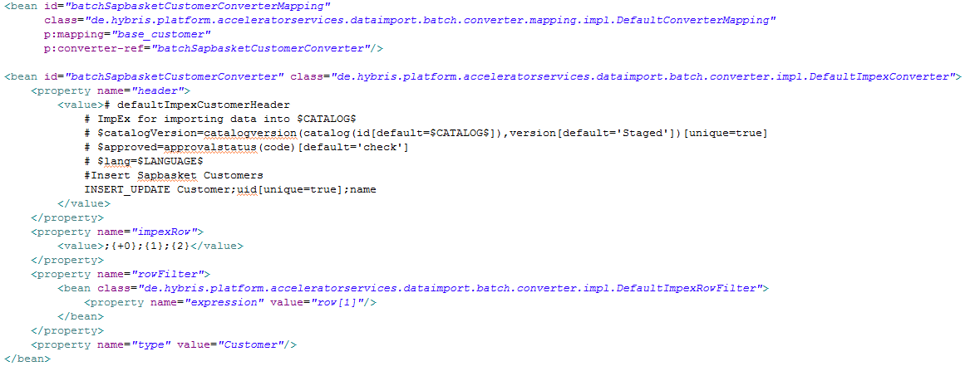

Now create your csv file with the same mapping name as given in convertermapping bean and add the date, timestamp.

For eg.

base_price-0203201710.csv

base_stocklevel-0203201710.csv

base_customer-0203201710.csv

Copy and paste the file at this location inside your hybris package hybris\data\acceleratorservices\import\master\sapbasket, as soon as the file is pasted there it goes into processing folder and than either in archive(if imports successfully) or error folder(if import is not successful).

If the file goes into archive the changes will now be reflected and we can verify.

So now we have successfully implemented hot folder integration for updating product and customer feeds.